KitchenAid®

User’s Manual Stand Mixer (model K45SSWH)
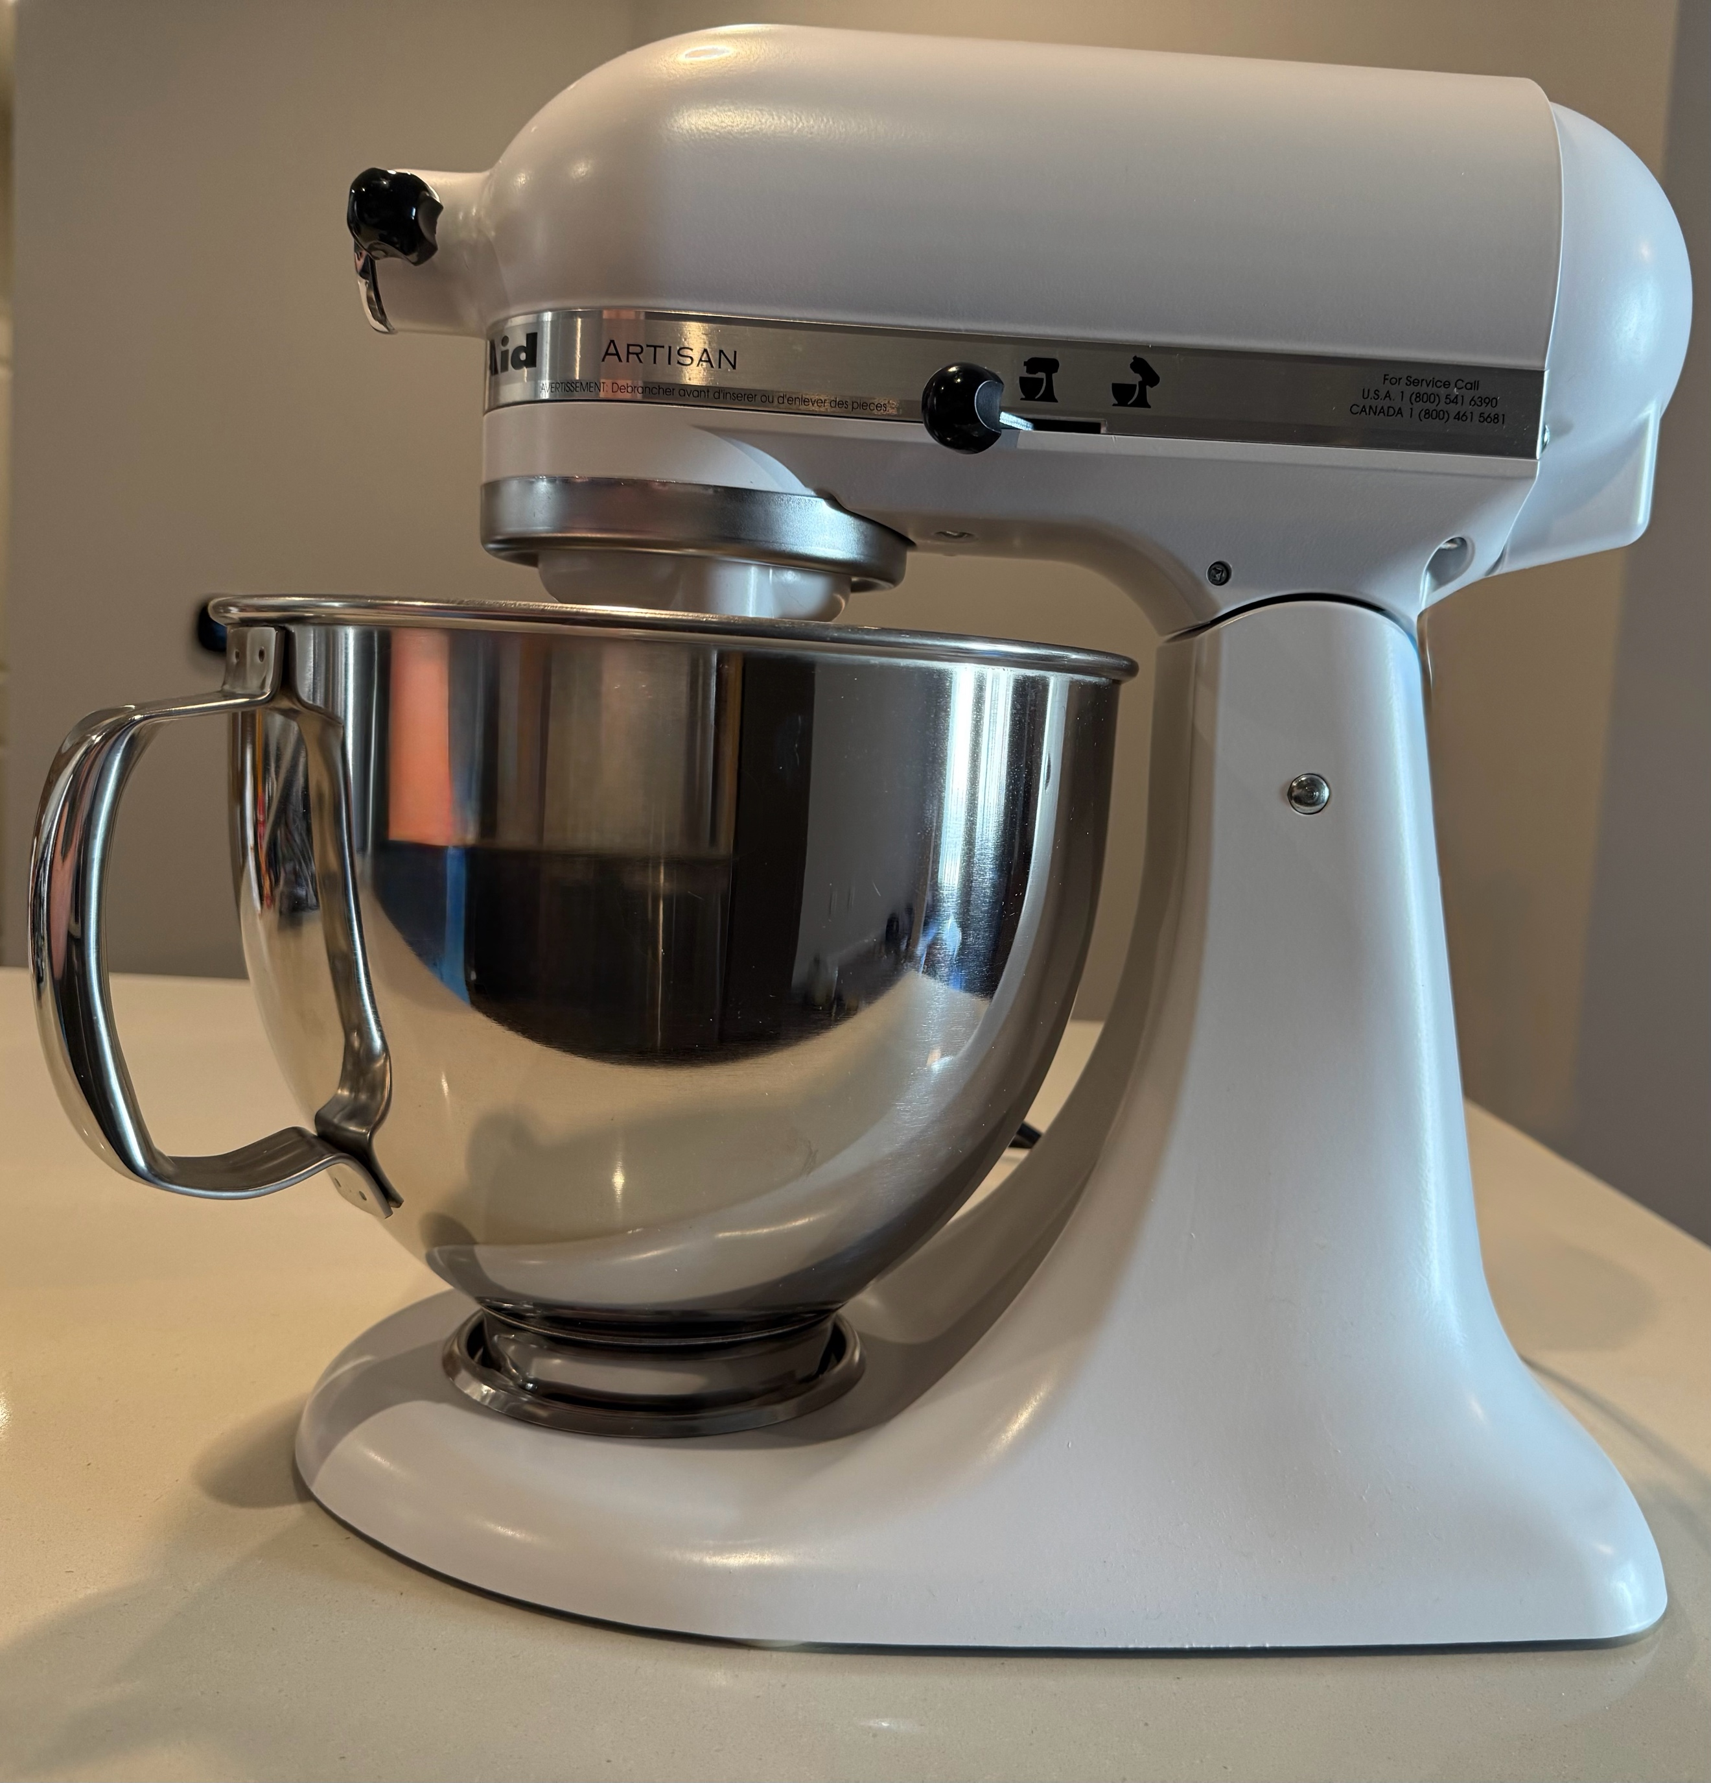

2.0 Table of Contents

1.0 Cover Page 1

2.0 Table of Contents 2

3.0 Introduction 3
3.1 Welcome to the KitchenAid Family 3
3.2 About KitchenAid 3
3.3 Product Overview 3
3.4 What’s in the Box (List of Included Accessories) 4

4.0 Technical Description 4
4.1 Specifications 4
4.2 Key Features and Components 4

5.0 Definition of Key Terms 5

6.0 Important Safeguards for Using Electrical Appliances 6

7.0 Frequent Issues and Troubleshooting Guide 7
7.1 The following section includes the four most common issues a user may encounter 7

8.0 Setup Instructions 8
8.1 Required Tools and Equipment 8
8.2 Setup Steps 9
8.3 Final Product 22

9.0 Speed Guide 23

10.0 Care and Maintenance 23

11.0 Warranty and Service 23

3.0 Introduction
3.1 Welcome to the KitchenAid® Family
Congratulations on your new KitchenAid® Stand Mixer – a timeless icon of craftsmanship, performance, and style. You’ve joined a tradition that began over a century ago, when KitchenAid introduced its first stand mixer in 1919 [2]. Since then, we’ve been committed to designing innovative, durable kitchen appliances that empower home cooks and professional chefs alike to create with confidence.
Your new stand mixer is more than just an appliance – it’s a culinary partner. From whipping delicate meringues to kneading hearty bread dough, it offers the versatility, power, and precision that make every recipe easier and more enjoyable. With a wide range of optional attachments, you can transform your mixer into a true kitchen hub, ready for everything from pasta making to food grinding.
We’re excited for you to experience the creativity, convenience, and quality that have made KitchenAid® a trusted name in kitchens worldwide. Welcome to a community that celebrates the joy of cooking, the art of baking, and the power of sharing great food.
Here’s to endless culinary possibilities – welcome aboard.
  - About KitchenAid®

Founded in 1919, KitchenAid has been a trusted name in kitchen innovation for over a century, renowned for its commitment to quality, durability, and timeless design. Best known for the iconic Stand Mixer, KitchenAid® offers a wide range of premium appliances that blend professional performance with everyday versatility. From powerful blenders to precision coffee makers, every KitchenAid® product is crafted to inspire creativity and help home cooks and professional chefs alike bring their culinary visions to life. With a heritage rooted in craftsmanship and a passion for food, KitchenAid continues to be a beloved companion in kitchens around the world [2,3].

  - Product Overview

The KitchenAid Classic™ Series 4.5-Quart Tilt-Head Stand Mixer (model K45SSWH) is a stylish and reliable countertop appliance designed to handle everything from everyday mixing to occasional baking projects. It includes a 4.5-quart stainless steel bowl, which is dishwasher-safe and can accommodate large batches such as up to six pounds of mashed potatoes, three loaves of bread, or six dozen cookies in a single go [1].

Made with a sturdy all-metal housing, this mixer is designed for durability, featuring planetary mixing with 59 touchpoints around the bowl to guarantee uniform and complete mixing. It’s powered by a 275-watt motor and offers 10 speed settings, from a gentle stir to a rapid whip, enabling precise control for a wide variety of recipes [1].

The tilt-head design makes it easy to add ingredients, attach the mixing accessories, and clean the bowl – plus, the head locks securely in place during operation. Included in the package are three core attachments: a coated flat beater, a coated dough hook, and a six-wire whip, covering both heavier dough and light whipping tasks.

For those who want more versatility, the power hub allows you to connect over 10 optional attachments, turning the mixer into a multifunctional culinary center – everything from pasta rollers to meat grinders are compatible.

In terms of size, the unit measures approximately 14″ deep × 8¾″ wide × 13⅞″ tall, weighs around 22 – 25 lbs, and includes a 4-foot power cord for convenient countertop placement.
In summary, the KitchenAid® K45SSWH is a dependable tilt-head mixer ideal for home bakers [1]. It offers a solid combination of capacity, speed options, durability, and versatility – perfect for everyday use and small-to-medium baking needs.

  - What's in the Box (List of Included Accessories)

- Stand Mixer (model K45SSWH)
- 4.5-Quart Stainless Steel Bowl
- Flat Beater
- Wire Whip
- Dough Hook

4.0 Technical Description
The KitchenAid Classic™ Series 4.5-Quart Tilt-Head Stand Mixer (Model K45SSWH) is a countertop appliance built for both novice and experienced bakers. Compact yet powerful, this mixer boasts a 275-watt motor housed in a durable all-metal frame, ensuring consistent performance and long-term durability. With 10 variable speed settings, users can execute everything from a gentle stir to a rapid whipping, catering to a wide range of mixing needs [1].
4.1 Specifications [1]
- Dimensions: 14″ deep × 8.75″ wide × 13.875″ tall
- Weight: Approximately 22 – 25 lbs
- Power: 275 watts
- Capacity: 4.5-quart stainless steel bowl
- Cord Length: 4 feet
- Material: All-metal housing with dishwasher-safe bowl and coated attachments
4.2 Key Features and Components
- Tilt-Head Mechanism
The tilt-head design allows the top of the mixer to lift back, giving users clear access to the bowl and beaters. This feature simplifies the addition of ingredients and the attachment or removal of accessories. Once in operation, the head locks into place, maintaining stability.

- Planetary Mixing Action
Unlike traditional mixers, the KitchenAid utilizes a planetary mixing motion, where the beater spins in one direction while the shaft rotates in the opposite direction. This results in 59 touchpoints per rotation, ensuring thorough and even mixing, similar to how the Earth rotates while orbiting the sun.

- Stainless Steel Bowl (4.5 Quart)
With a generous capacity that holds enough batter for six dozen cookies or three loaves of bread, this bowl is built for both big jobs and easy cleanup. It's not only lightweight and durable but also completely dishwasher-safe.

- Speed Control Dial (10 Speeds)
Located on the side of the mixer, the numbered dial allows for intuitive speed adjustments. Lower settings are ideal for gentle mixing (e.g., folding), while higher settings are used for vigorous beating or whipping.

- Attachment Hub
At the front of the mixer lies the power hub, covered by a removable metal cap. This hub accommodates over 10 optional attachments, transforming the mixer into a multipurpose food processor capable of rolling pasta, grinding meat, or spiralizing vegetables.

- Mixing Accessories
Included are three primary tools: a coated flat beater (ideal for batters and mashed potatoes), a coated dough hook (for bread and pizza dough), and a six-wire whip (for whipping cream or egg whites).

Together, these components create a cohesive, user-friendly machine. The tilt-head enables access, the motor powers precision mixing, and the planetary action ensures even distribution. Imagine the mixer as an orchestra: the motor is the conductor, the attachments are the instruments, and the planetary mixing action is the rhythm that ties it all together, producing a perfect culinary symphony every time.

5.0 Definition of Key Terms
Tilt-Head Mechanism: A design feature that allows the mixer head to tilt backward, providing easy access to the mixing bowl and beaters for adding ingredients, attaching accessories, and cleaning. The head locks securely during operation to maintain stability.

Planetary Mixing Action: A mixing method where the beater rotates in one direction while the drive shaft turns in the opposite direction, creating multiple touchpoints around the bowl for thorough and consistent mixing.

Stainless Steel Bowl (4.5 Quart): A durable, dishwasher-safe mixing bowl with a capacity to handle large batches, such as up to six dozen cookies or three loaves of bread.

Speed Control Dial (10 Speeds): A numbered control mechanism on the side of the mixer that allows users to select different speeds, from gentle stirring to rapid whipping, to suit various mixing needs.

Attachment Hub: A power-driven socket located at the front of the mixer, covered by a removable metal cap, that enables the use of over 10 optional accessories such as pasta rollers, meat grinders, or vegetable spiralizers.

Flat Beater: A coated mixing attachment designed for general-purpose mixing tasks such as batters, cookie dough, and mashed potatoes.

Dough Hook: A coated attachment shaped for kneading yeast-based doughs, including bread and pizza dough.

Wire Whip: A six-wire whisk attachment designed for incorporating air into mixtures, ideal for whipping cream, beating egg whites, or preparing meringues.

All-Metal Housing: The sturdy outer construction of the mixer, made entirely from metal for enhanced durability, stability, and longevity.

Power Hub Attachments: Optional tools that can be connected to the mixer’s attachment hub to expand functionality beyond mixing, including food grinding, pasta making, and vegetable processing.


6.0 Important Safeguards for Using Electrical Appliances
To ensure safe operation of your Stand Mixer, always observe the following precautions:
- Carefully read and follow all instructions before use.
- To reduce the risk of electric shock, never immerse the Stand Mixer in water or any other liquid.
- This appliance should not be used by children or by anyone with reduced physical, sensory, or mental capabilities. It also shouldn't be used by anyone who lacks experience or knowledge, unless they are being closely supervised and instructed by a responsible adult. Keep children under close supervision to make sure they don't play with the appliance.
- Always make sure the stand mixer is OFF/0 and unplugged before you assemble or disassemble any parts, before you clean it, and when you're not using it. To unplug the mixer, always pull on the plug, not the cord.
- To diminish the risk of personal injury and damage to the appliance, keep your hands, hair, clothing, spatulas, and all other utensils clear of the mixer's moving parts when it's on.
- Do not operate the mixer if the cord or plug is damaged, if the appliance malfunctions, or if it has been dropped or damaged in any way. Contact an Authorized Service Facility for examination, repair, or adjustment.
- Use only accessories and attachments recommended or sold by the manufacturer. Using unauthorized parts may result in fire, electric shock, or injury.
- Do not use the Stand Mixer outdoors.
- Prevent the cord from hanging over the edge of a table or countertop where it could be pulled or tripped over.
- Remove all mixing attachments, including the Beaters, Pastry Beater, Wire Whip, and Dough Hook, before washing.

SAVE THESE INSTRUCTIONS
This product is intended for household use only.

7.0 Frequent Issues and Troubleshooting Guide

7.1 The following section includes the four most common issues a user may encounter [1].

Problem | Solution
Speed Control Lever is hard to move: | Lift the lever slightly while sliding it across the speed settings in either direction.
Flat Beater contacts the bowl: | Turn the mixer off and unplug it. Check and adjust the beater-to-bowl clearance as described in the Setup Instructions section.
Mixer feels warm during use: | Under heavy loads and extended mixing, the top of the unit may become too warm to touch comfortably. This is normal.
Mixer will not operate: | Confirm the mixer is firmly plugged into a working outlet.
Mixer will not operate: | Check the circuit fuse or breaker and reset/replace if needed.
Mixer will not operate: | Turn the mixer off for 10–15 seconds, then turn it back on.
Mixer will not operate: | If it still does not start, allow the unit to cool for 30 minutes before trying again.
Note: If the problem persists after these steps, contact an Authorized Service Facility.

8.0 Setup Instructions
8.1 Required Tools and Equipment
- KitchenAid Classic™ Series 4.5-Quart Tilt-Head Stand Mixer (Model K45SSWH)
- 4.5-quart stainless steel mixing bowl
- Coated flat beater, coated dough hook, or six-wire whip (as needed for initial use)
- Clean, dry kitchen counter space

!!! Warning !!!
Serious Injury Hazard
Unplug the mixer before installing, removing, or adjusting the beaters.
Failure to do so may cause fractures, cuts, or bruises.

8.2 Setup Steps
Step 1: Remove the mixer and accessories from the packaging.
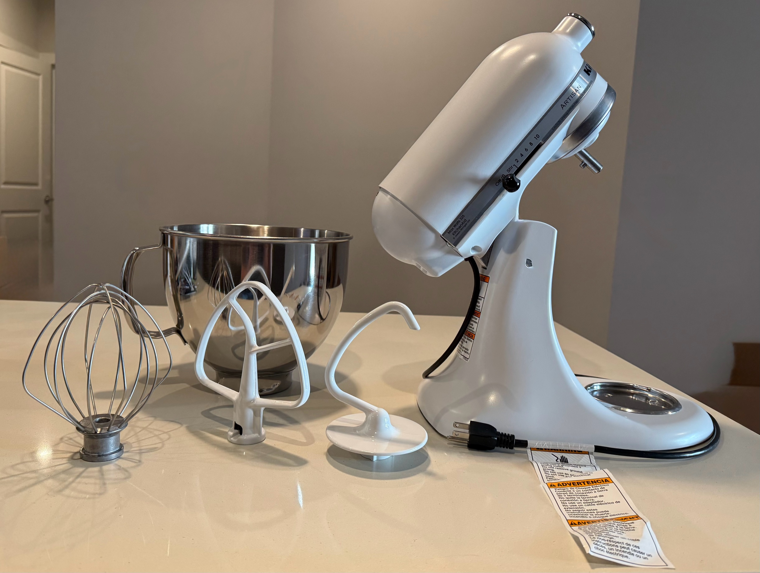

Step 2: Inspect the mixer and accessories for any shipping damage.
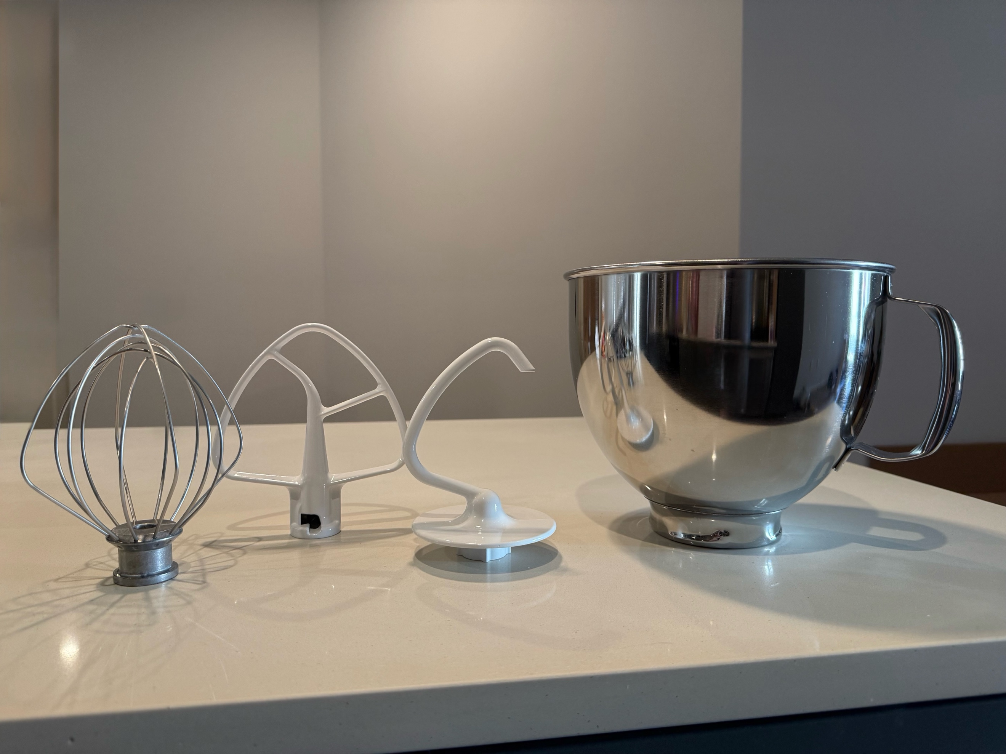

Step 3: Place the mixer on a flat, stable surface near a power outlet.
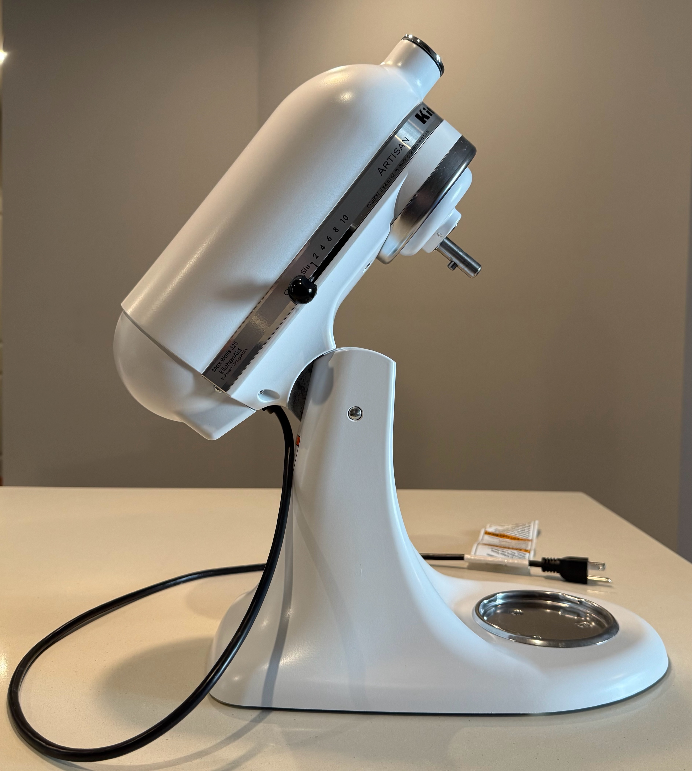

Step 4: Ensure the tilt-head is locked by pushing the locking lever into place.
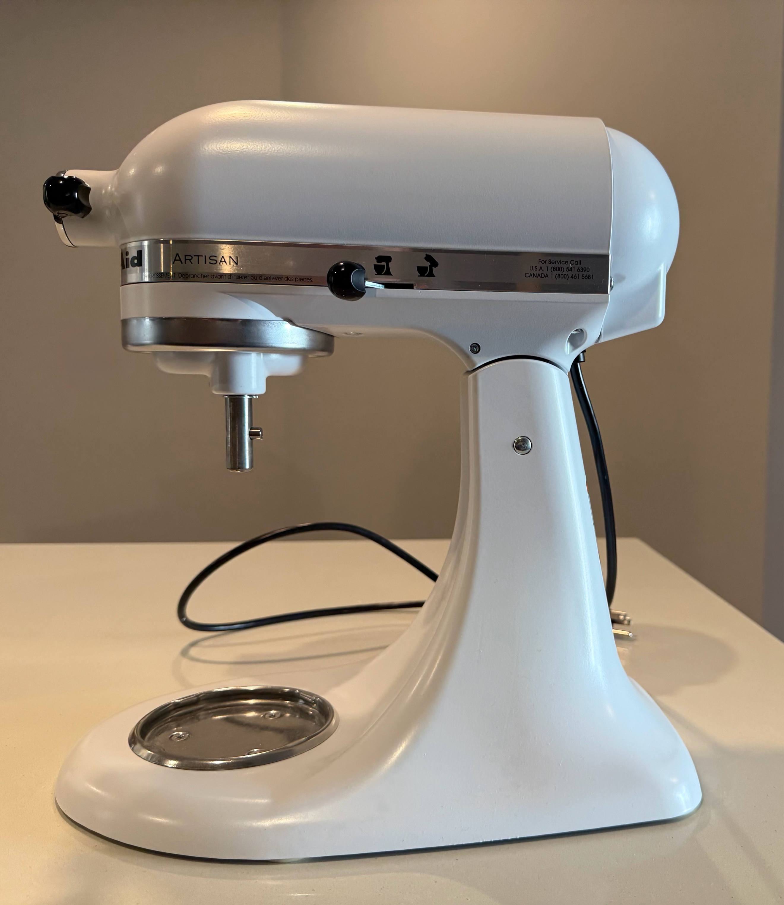

Step 5: Attach the mixing bowl by fitting it into the bowl-clamping plate and turning clockwise until secure.
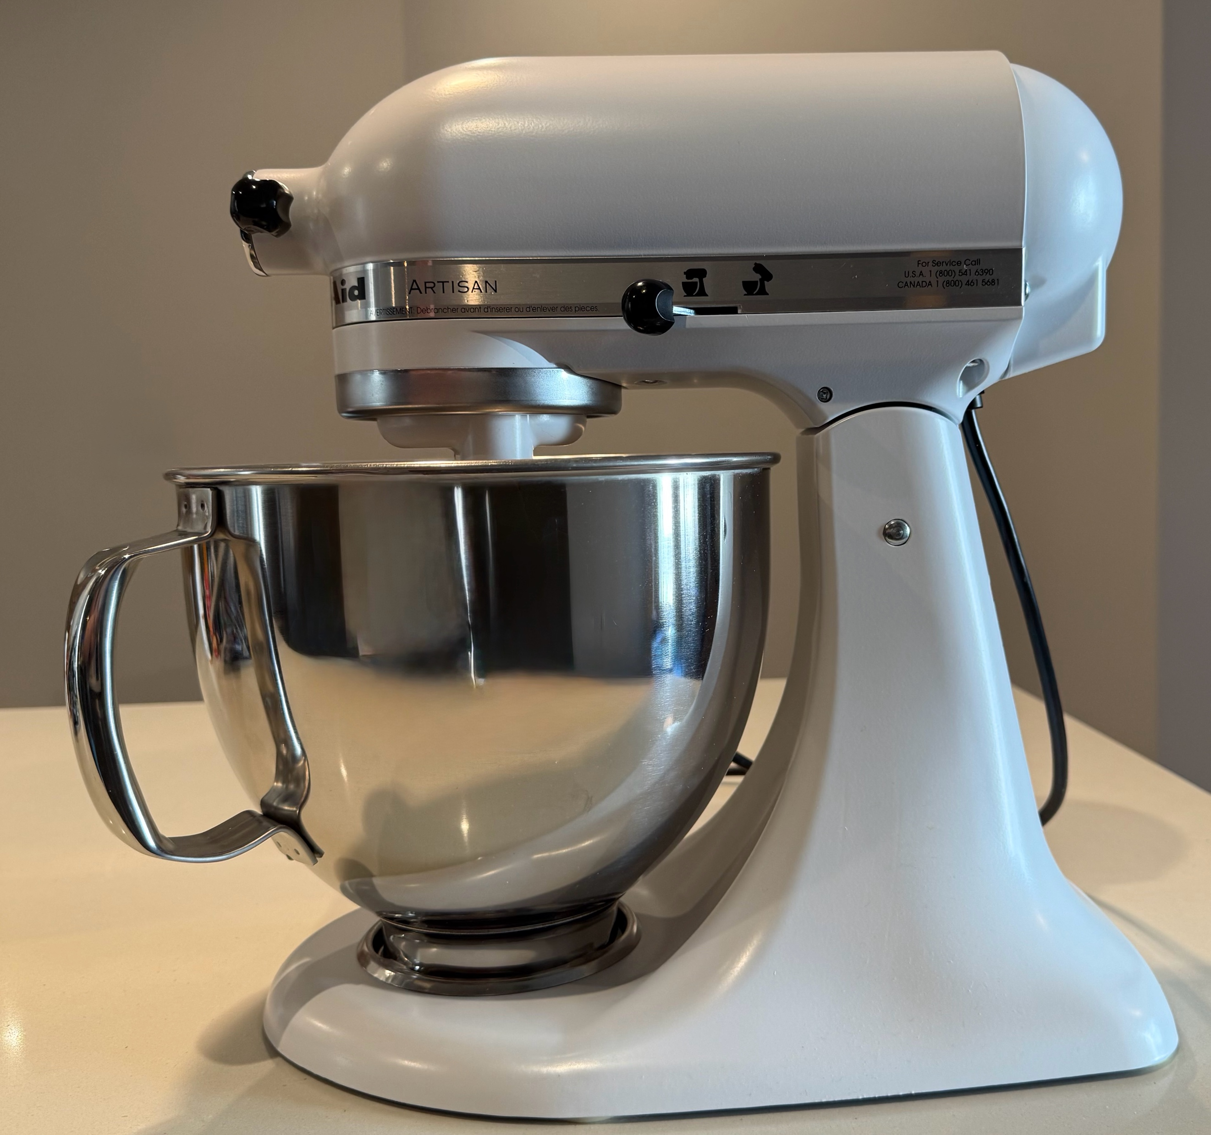
Step 6: Select your attachment (flat beater, dough hook, or wire whip) and align it with the beater shaft.
!!! Warning !!!
Serious Injury Hazard
Unplug the mixer before installing, removing, or adjusting the beaters.
Failure to do so may cause fractures, cuts, or bruises.
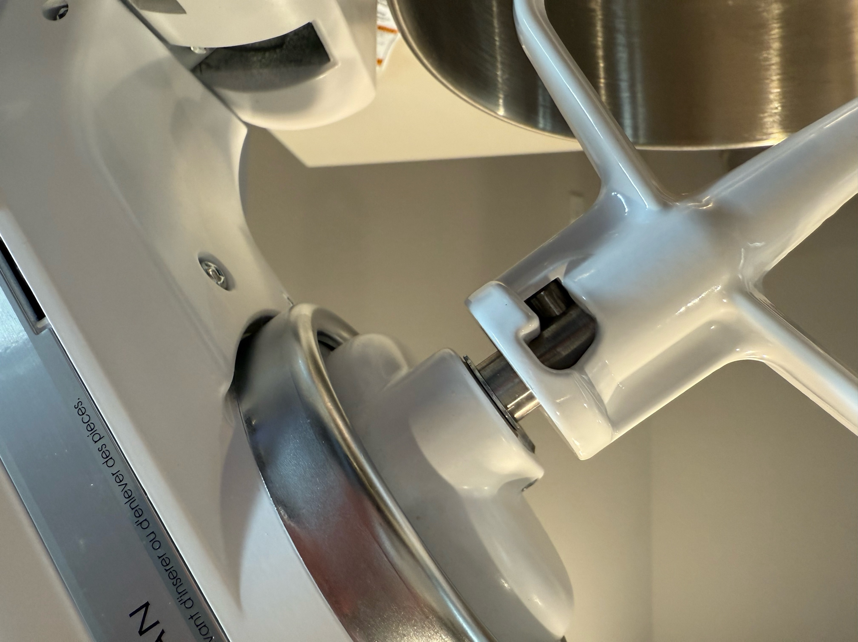

Step 7: Push the attachment up and turn it clockwise until it locks into place.
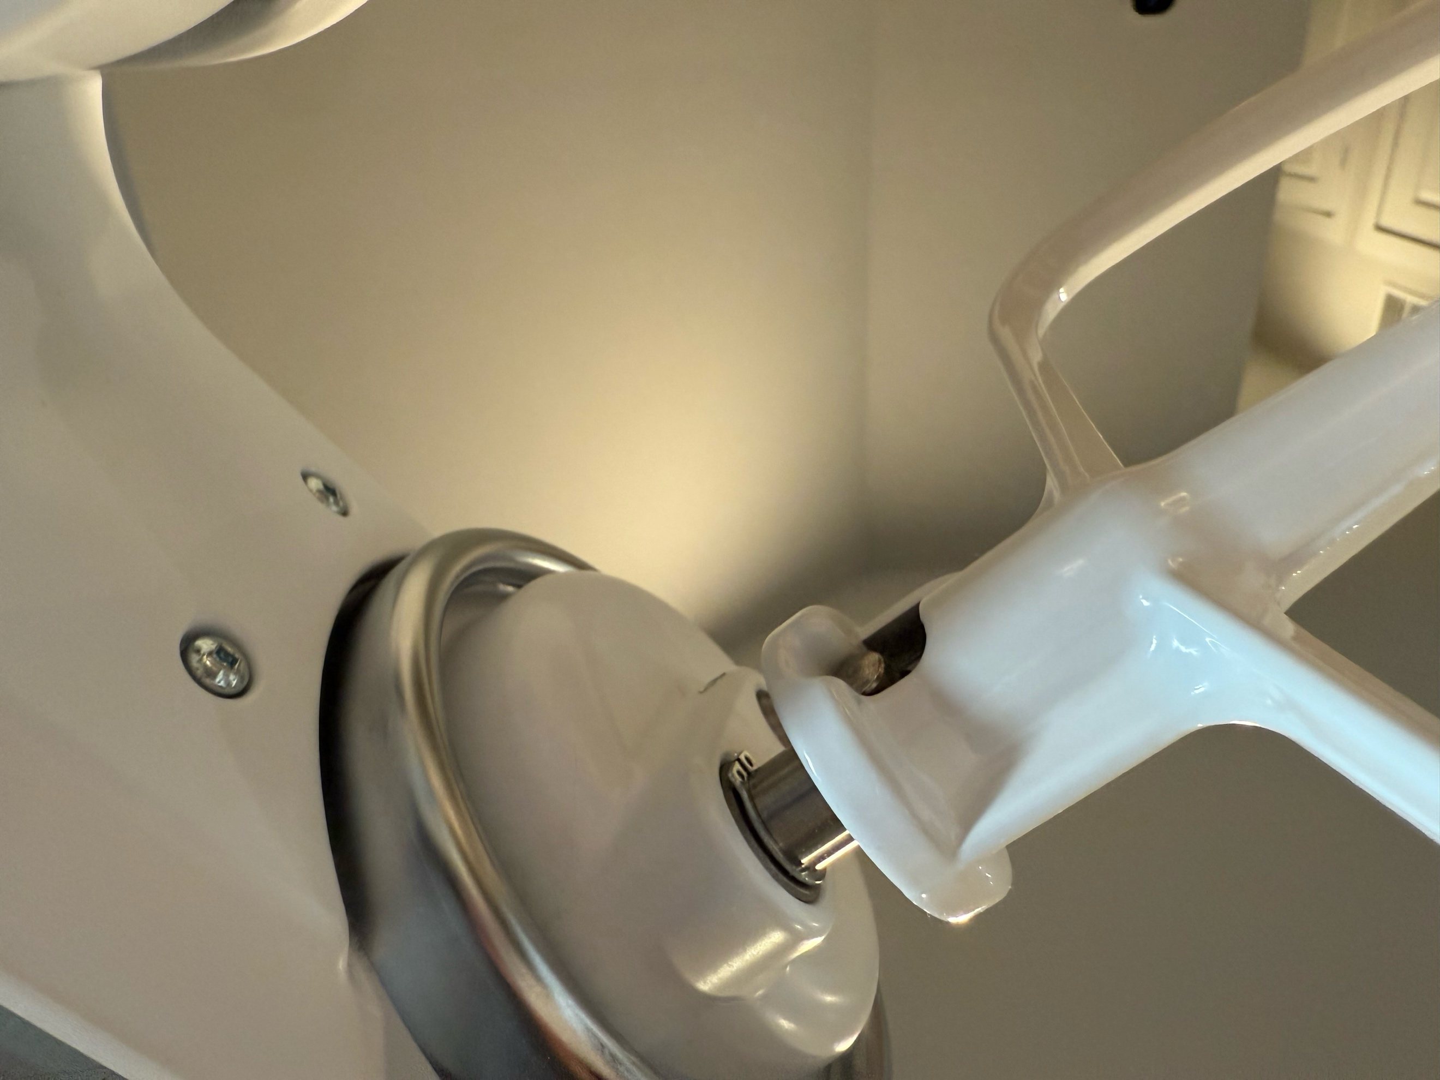
!!! Warning !!!
Serious Injury Hazard
Unplug the mixer before installing, removing, or adjusting the beaters.
Failure to do so may cause fractures, cuts, or bruises.

Step 8: Unlock the tilt-head by moving the locking lever and gently tilt the head back.
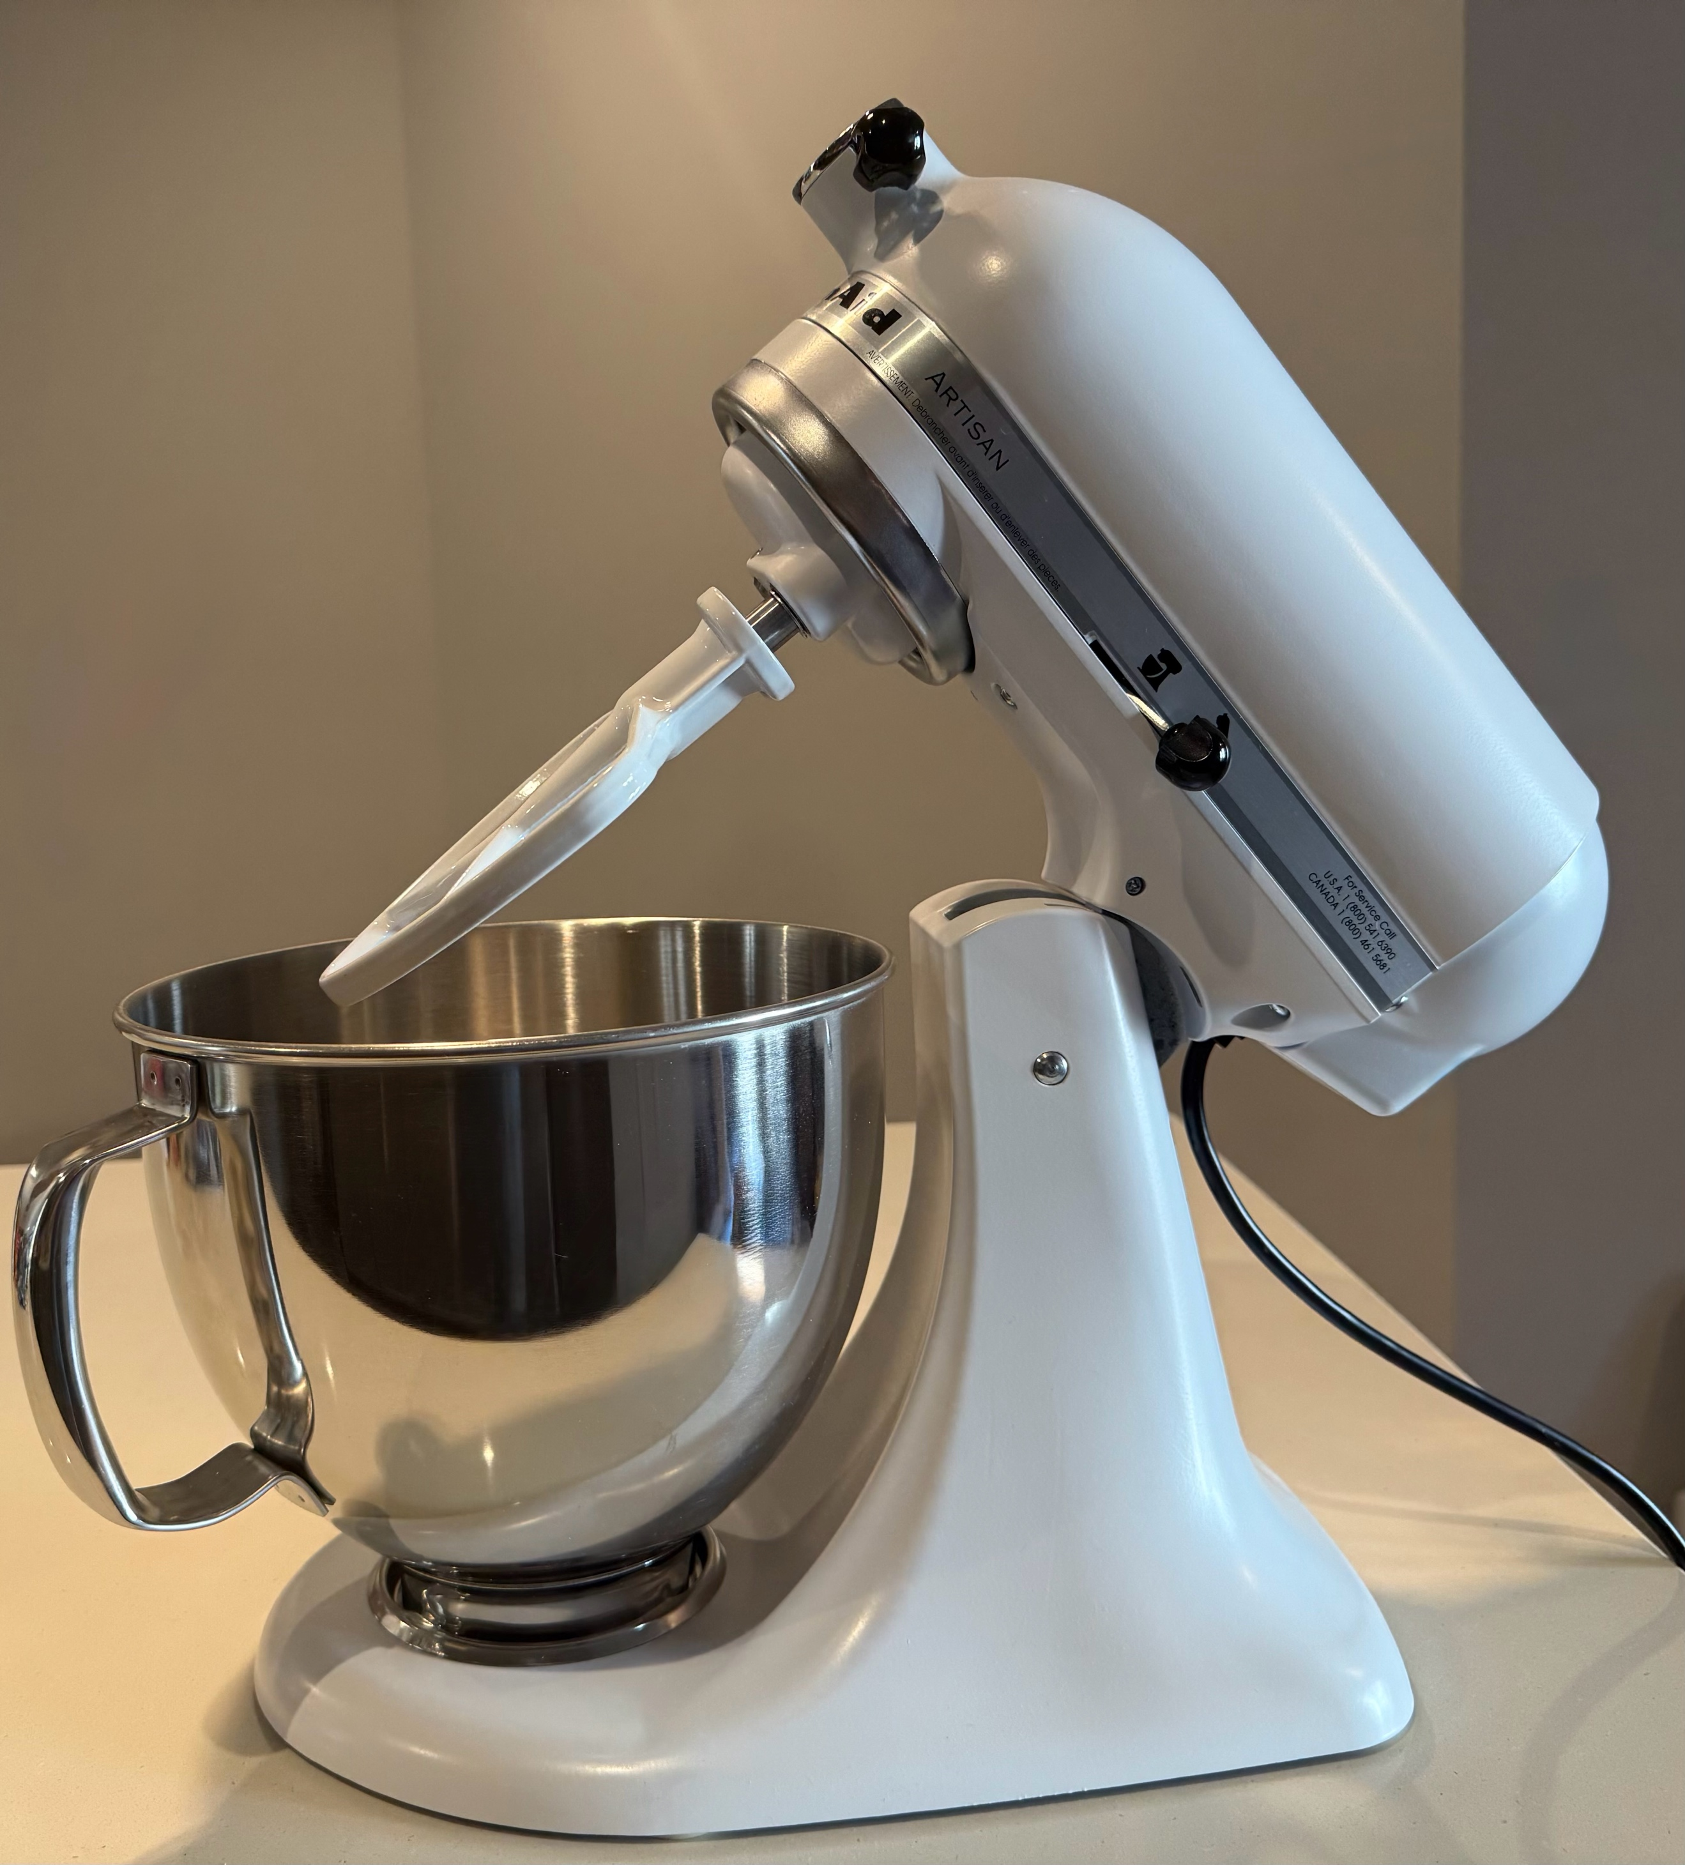

Step 9: Add ingredients to the mixing bowl according to your recipe.
Step 10: Return the tilt-head to the down position and lock it in place.

Step 11: Plug the mixer into a grounded outlet.
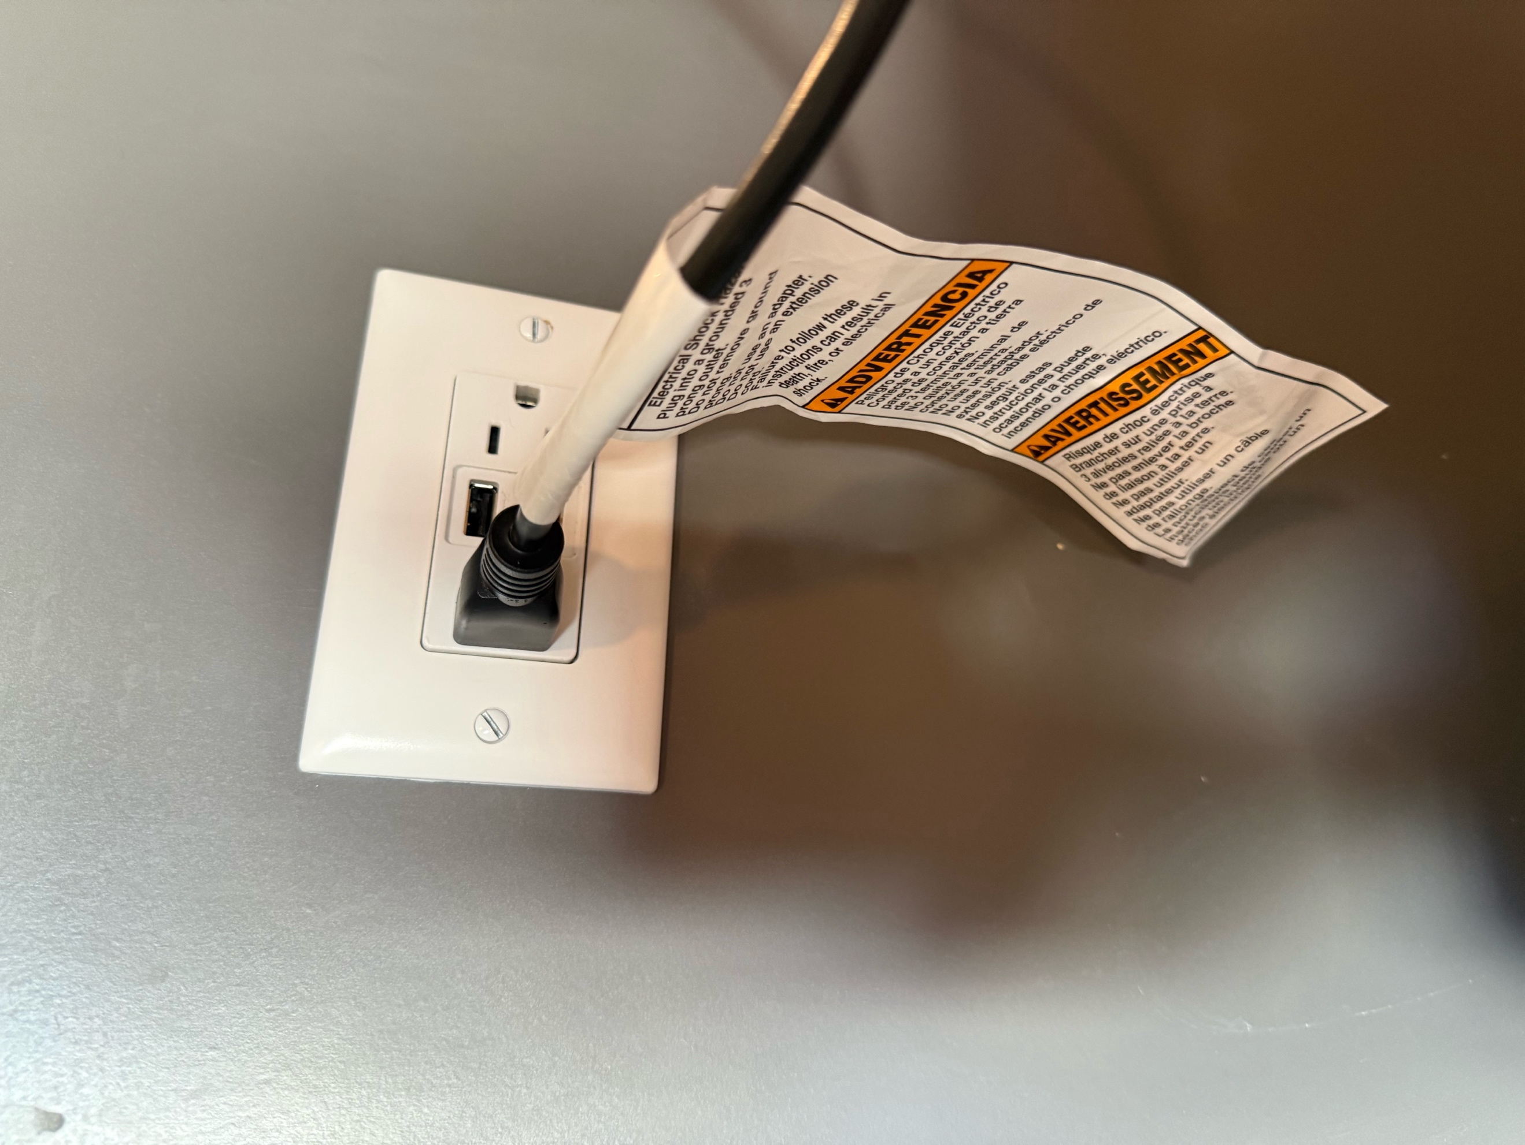

Step 12: Turn the speed control lever to the desired setting. Refer to the Speed Guide for optimal settings.
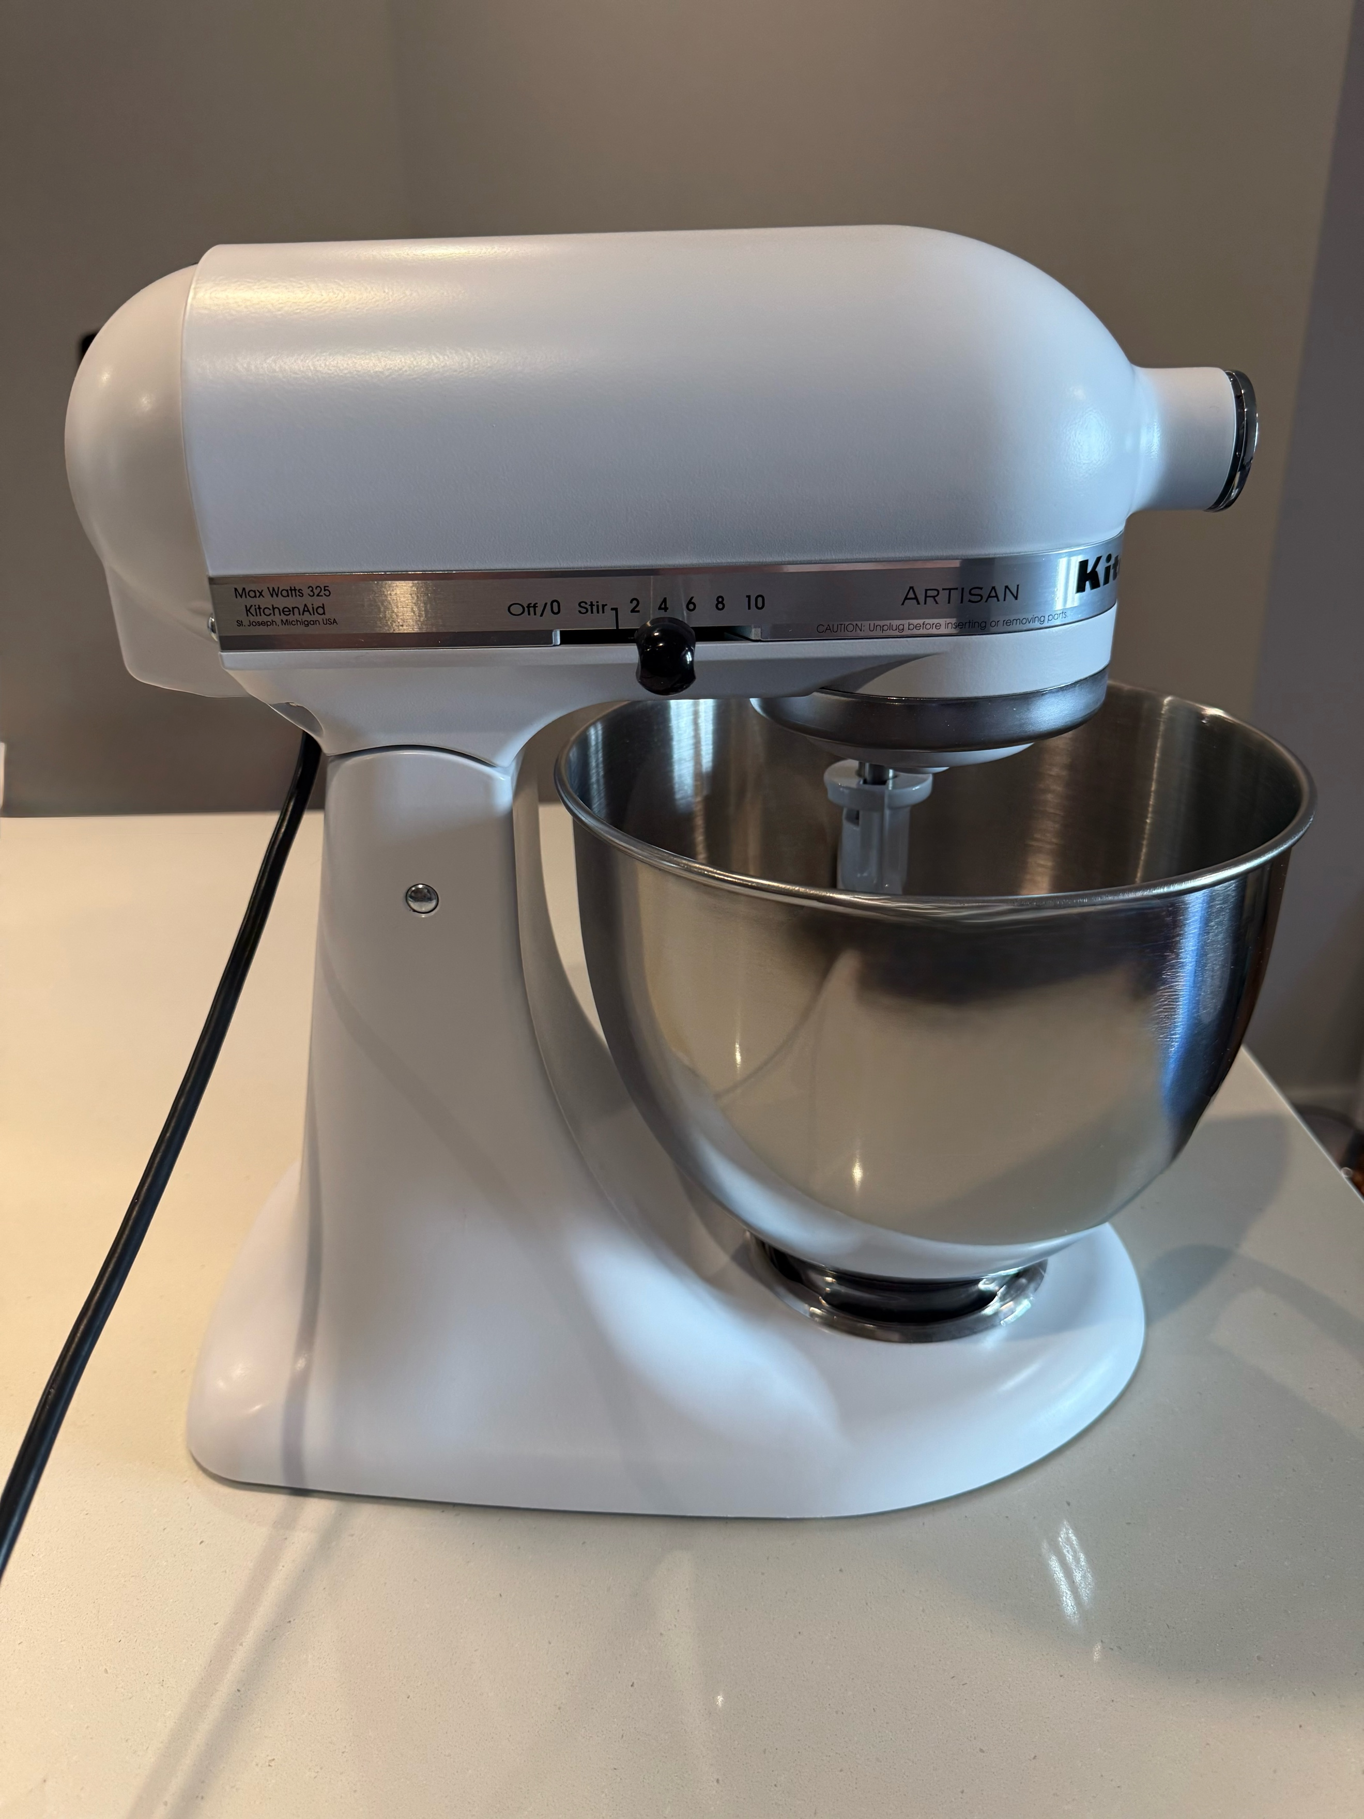
Step 13: Allow the mixer to operate until mixing is complete, then turn the speed control to “OFF/0” before switching attachments or cleaning.
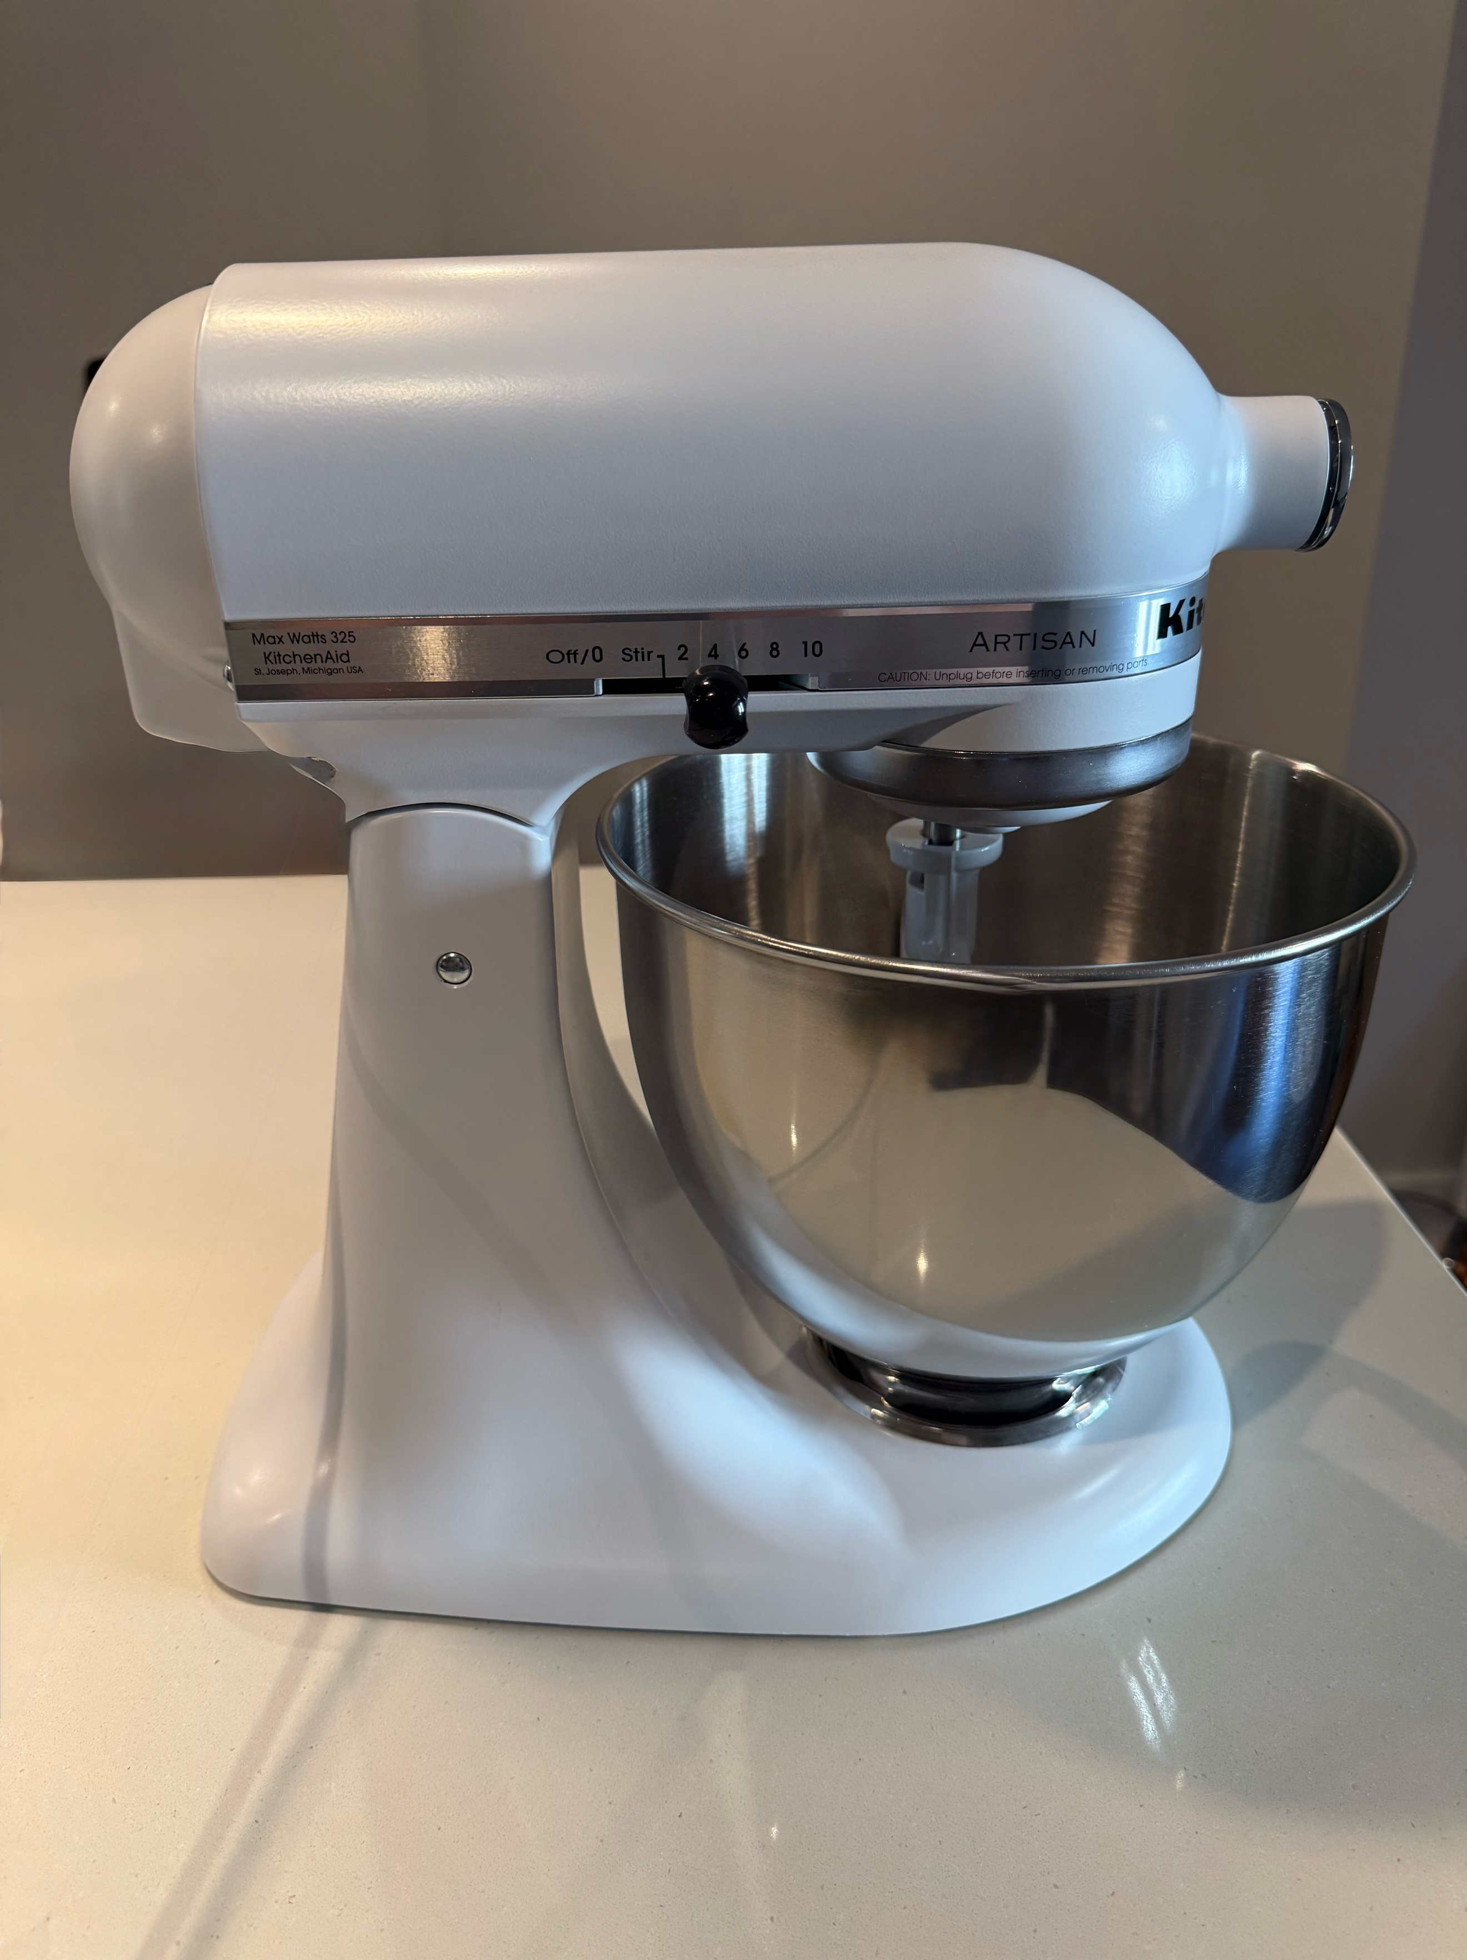
Step 14: Unplug the mixer when finished and clean all used components.
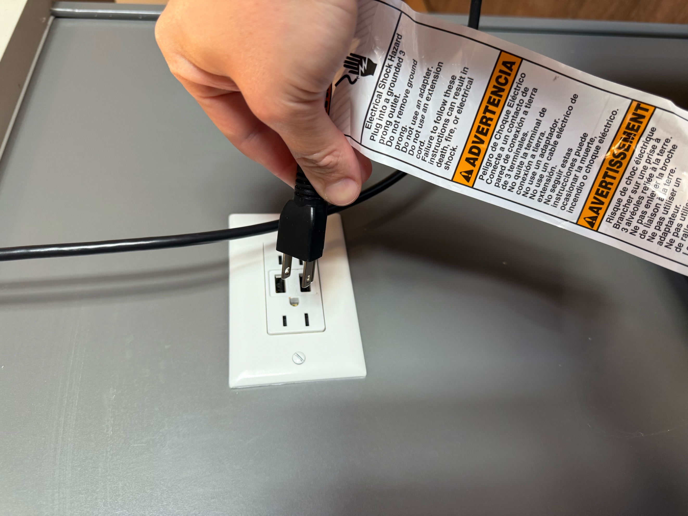
8.3 Final Product
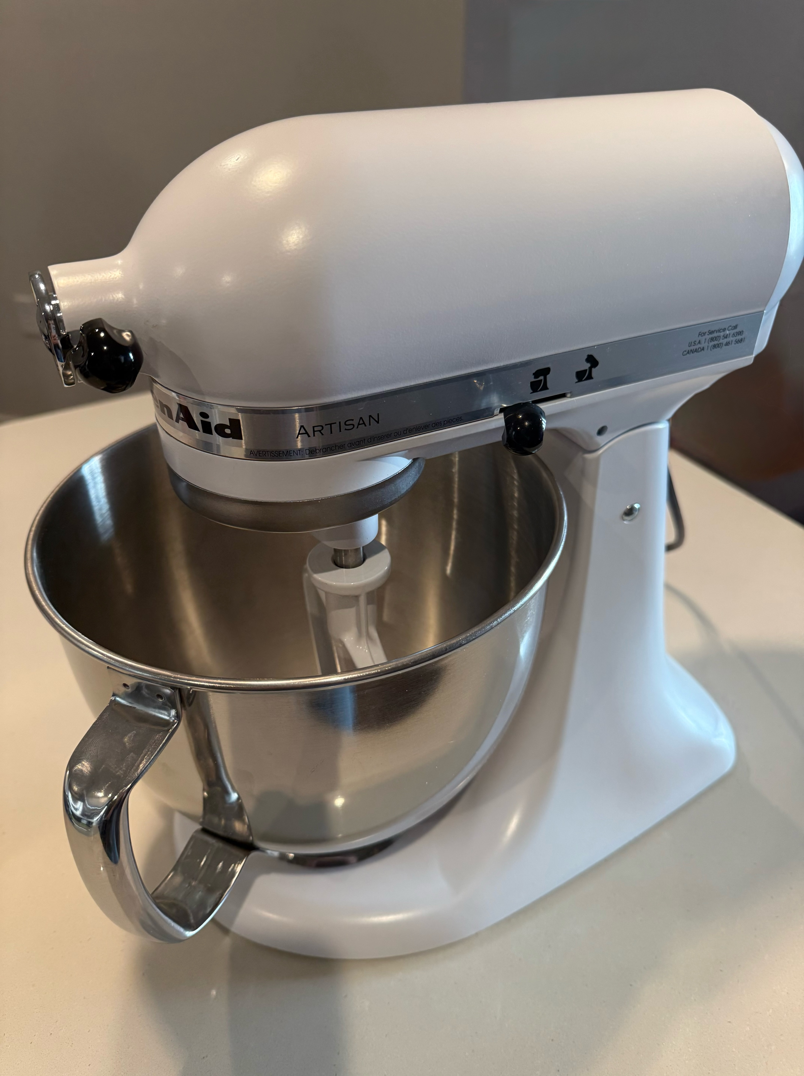

9.0 Speed Guide

Setting [1] | Typical Uses / Notes [1]
Stir (Speed 1) | Starting mixtures; combining dry ingredients; preventing splashing.
Slow Mix/Knead (Speed 2) | Kneading yeast doughs; adding heavy ingredients. Do not exceed Speed 2 for kneading.
Mix (Speed 4) | Cake mixes, cookie dough, quick breads; creaming butter and sugar.
Beat (Speed 6) | Medium‑high beating for frostings, mashed potatoes, and batters.
Whip (Speed 8) | Fast whipping for cream and soft peaks.
Fast Whip (Speed 10) | Maximum aeration for egg whites; meringues and stiff peaks.

10.0 Care & Maintenance

- Unplug before cleaning. Clean the mixer's exterior by wiping it with a damp cloth; dry thoroughly.
- Bowl and coated attachments: dishwasher‑safe (top rack recommended).
- Do not immerse the mixer body, power cord, or plug in water or any liquid.
- Inspect cord and plug periodically; discontinue use if damaged.
- Store with the speed control at OFF/0 and the tilt‑head locked.

11.0 Warranty and Service

A one-year warranty is included with your stand mixer and its accessories, beginning on the original date of purchase.

All repairs need to be performed at Authorized KitchenAid Service Centers. KitchenAid will pay for your choice of:
- Hassle-Free Replacement of your Stand Mixer
- Parts
- Accessories
- Labor cost

KitchenAid will not pay for:
- Repairs performed at unauthorized service centers
- Damages resulting from incorrect use
- Any alterations to accessories or the stand mixer
- Shipping cost to authorized service centers

Reference:
[1] Stand Mixer K45 Series, KSM45 – KSM200 Series, KitchenAid User’s Manual

[2] About KitchenAid. 2025. https://www.kitchenaid.com/resources/about-us.html?_gl=1*1g6uc2w*_up*MQ..*_gs*MQ..&gclid=CjwKCAjwkvbEBhApEiwAKUz6-xrmz2Y6Dmnd7mzBq4HagC49Wh26kSben603yUk0vlNc2ljj1U_CdBoCGtIQAvD_BwE&gclsrc=aw.ds&gbraid=0AAAAAC5rhmJkdjwih3h-H9FlEE9NE1jII

[3] KitchenAid. 2025. https://en.wikipedia.org/wiki/KitchenAid

